**INTRODUCTION:**

* **Overview:**
* A Radisson hotel system is one of the greatest hotel service which are done by the Radisson hotel servants or employees
* By analyzing the performance and efficiency of the Radisson hotel by using data visualization we had come to know that they are satisfying the customer needs

**PROBLEM DEFINITION & DESING THINKING:**

* **Empathy map:**

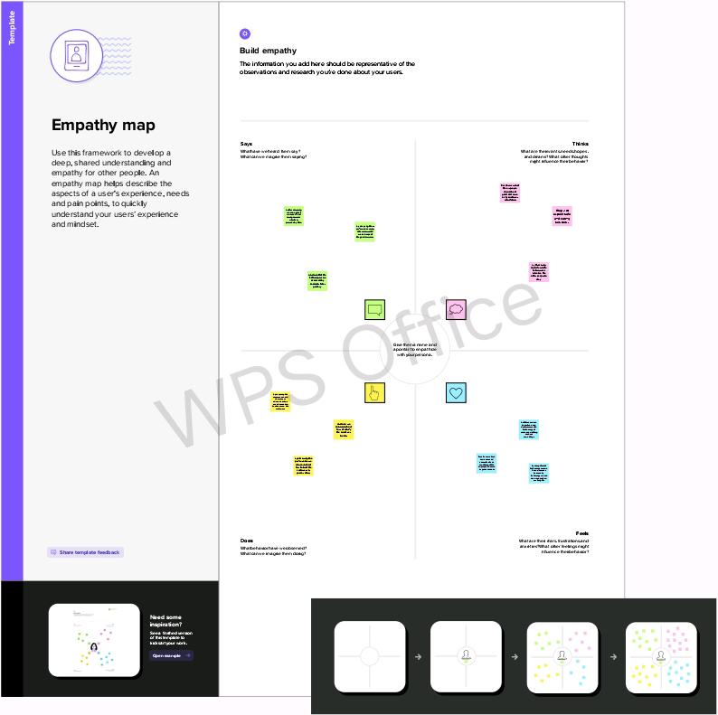

* **Ideation & Brainstorming ma**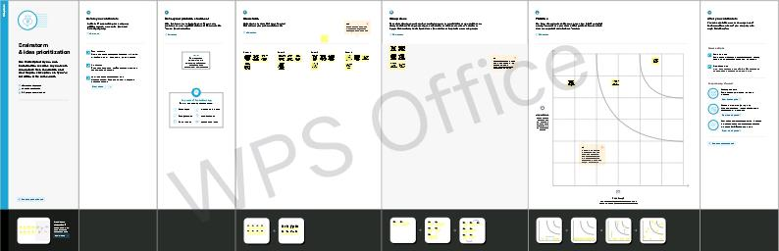

# RESULT:

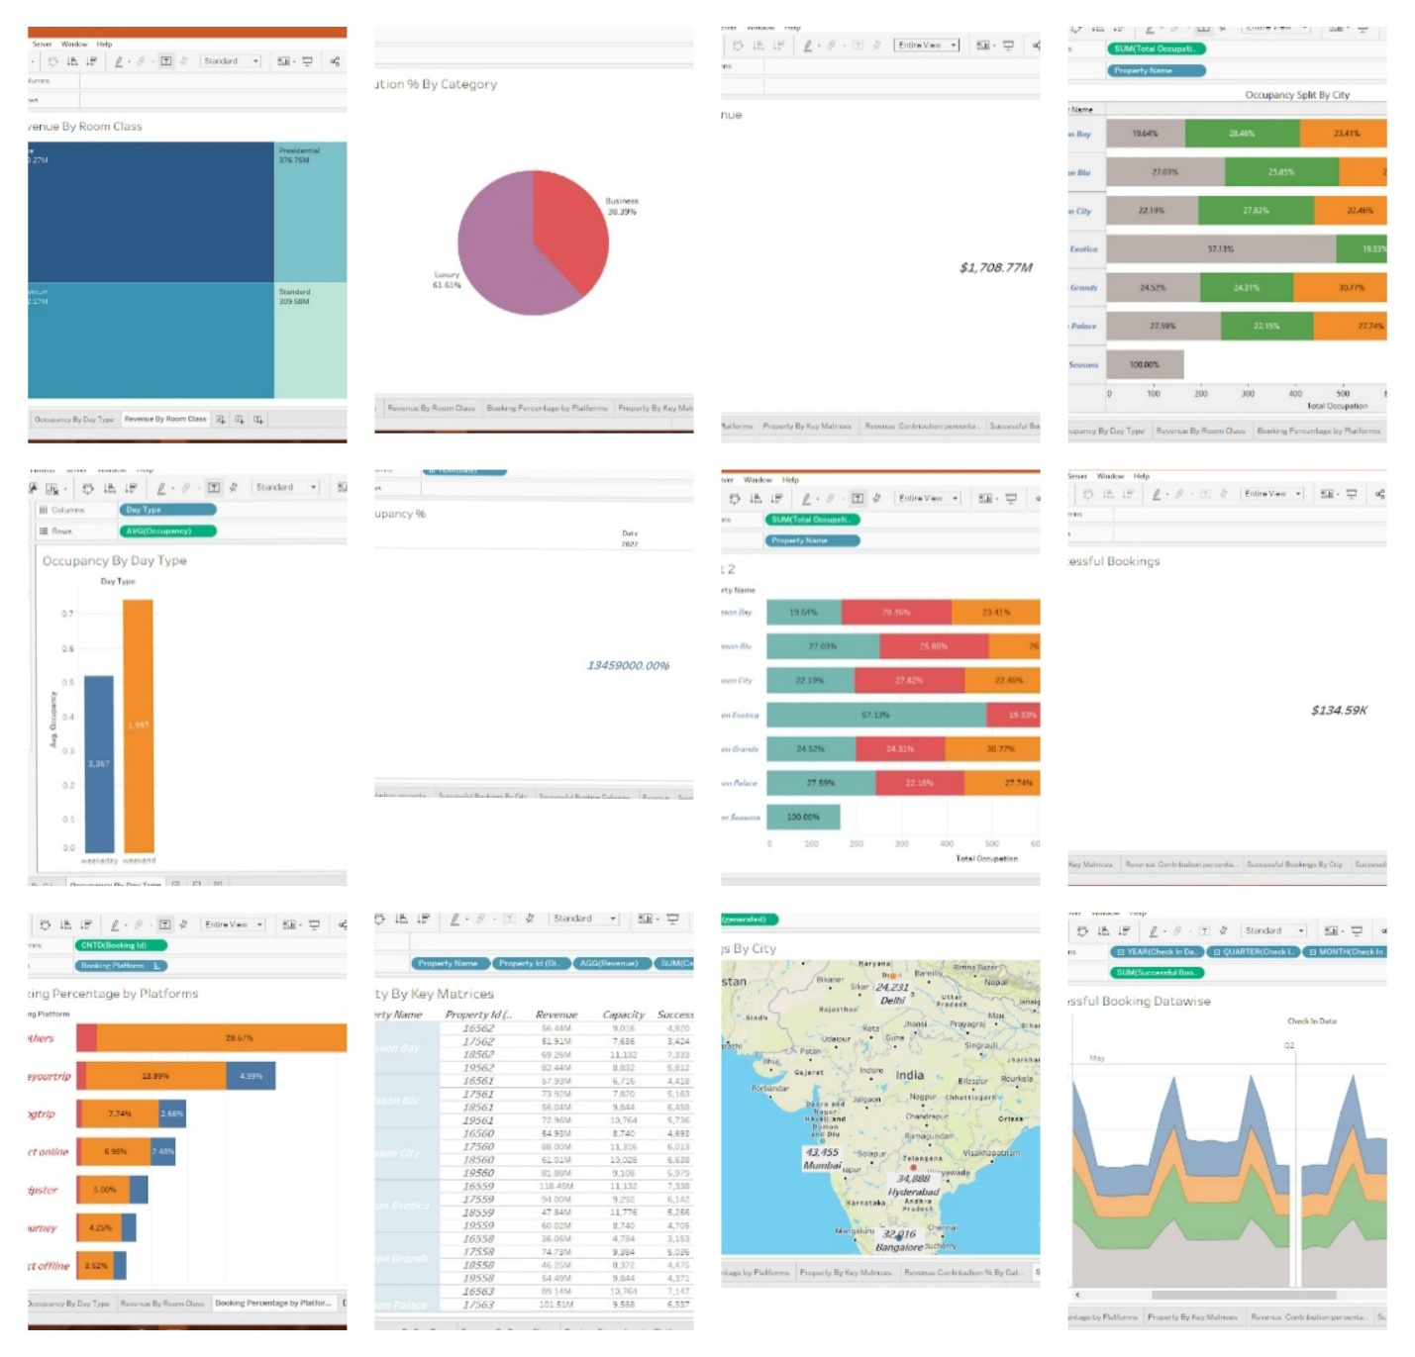

**ADVANTAGES & DISADVANTAGES:**

* **Advantages:**
* Visualized data is processed faster.
* Data visualization dashboards support visual learness.
* Data visualization tools show insights that may be missed in traditional reports.
* Data visualization gives actionable items.
* Data visualization increases productivity and sales.

* **Disadvantages:**
* A business is influenced by a lot of elements.
* There is lack of inroom technology
* Radisson hotels not economically friend for poor and middle class family
* **Applications:**

**1.Healthcare industries**

* Healthcare is a time-consuming procedure,and the majority of it is spent evaluating prior reports

**2.Military**

* It is critical to collect data from a variety of sources, both organized and unstructured

**3.Finance industries**

* Improved business prospects,data visualization emphasizes the most recent trends.

**CONCLUSION:**

Radisson Hotel Group is a name synonyms with creative hospitality and innorive sprit our growth strategies and unique business model make us one of the most attractive and respescted partners in the industry

* **SCOPE:**
* Machine learning and AI utilize their natural language processing capabilities to generate insights
* **Operational alerting:**
* It enables sales, marketing,internal process teams to say informed about any new promotion product launch or more. Data visualization allows sending visual alerts to the teams in real-time

l